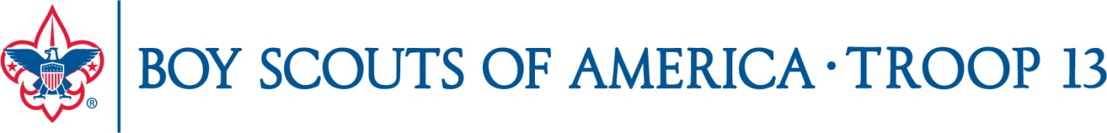

The Boy Scout Uniform

The Boy Scout uniform must be worn to all Troop activities: weekly meetings, Scouting for Food, Rummage Sale, Boards of Review, Scoutmaster Conferences, Courts of Honor, closing ceremony at Summer Camp, etc.

Class A Uniform consists of:

--Scout Shirt with all insignia (US Flag, National Capital Area Council Patch, numerals 13, Patrol patch (provided by Troop 13). The correct placement of insignia is shown on the inside cover of the Scout Handbook. Many parents find the use of Badge Magic (available from the Scout Shops) makes it easier to attach patches and badges.

--Scout pants and belt (some pants are available with an integrated belt)

--Scout socks

--Troop 13 neckerchief and slide (provided by the Troop)

The Troop has a uniform exchange area in the Scout Closet. Feel free to browse for a shirt or pants that may fit your Scout. Please also consider donating outgrown items to the collection. Please keep the uniform exchange neatly organized so that others can find items they need.

Uniform items are available from www.scoutstuff.org and Scout Shops:
National Capital Area Scout Shop:  9190 Rockville Pike, Bethesda, MD 20814-3897 | Northern VA Scout Shop – (Braddock Rd & I-495):  5234 Port Royal Road, Springfield, VA 22151
phone (301) 564-1091 (301) 564-6028 fax | phone (703) 321-4836 (703) 321-4838 fax
Mon, Tues, Wed, and Fri: 9 am - 5:30 pm  Thurs: 9 am - 8 pm Saturday: 10 am - 3 pm | Monday to Friday: 9 am -7 pm  Saturday: 10 am - 5 pm

Class B uniform is permitted at weekly meetings during the summer after Fairfax County Public Schools are released for the summer and through Labor Day. Class B is any Scout-related t-shirt and Scout pants or Scout shorts. Class B can include Troop 13 T-shirts distributed to those attending Summer Camp. Class B is not acceptable for Scoutmaster Conferences or Boards or Review held during the summer.

